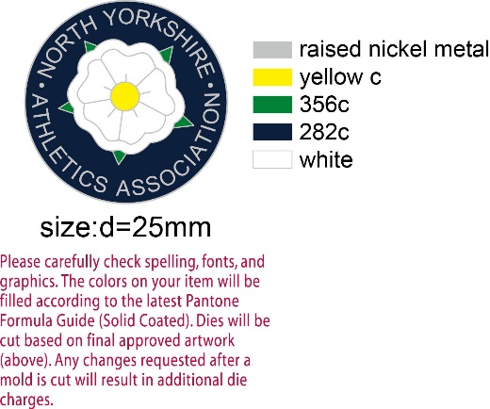**NORTHERN SCHOOLS INTER - COUNTIES**

**CROSS-COUNTRY MATCH**

**SATURDAY 4th FEBRUARY 2023**

**FARRINGDON SCHOOL, SUNDERLAND**

**TRAVEL ARRANGEMENTS + PARKING**

Please can you use the following address for the event and parking:

Silksworth Sports Complex,

Sunderland,

SR3 1PD

As you may see, this is approx 1.3km from the start/finish area, at the moment this is the only parking secured for the IC event. I will send an update if this changes.

**On the Day**

Please arrive with plenty of time before your race. This will allow registration and numbers to be distributed (please bring Safety pins). The first race is at 12.30pm, so have this in mind especially if you are wanted to walk the course.  Registration needs to be made at the North Yorkshire tent/Base.

We have a very large and strong team scheduled to race on the day (100 athletes). Please understand that staff will therefore require athletes to take responsibility with punctuality and preparation.

**Kit**

Collected on the day at the North Yorkshire registration.

Athletes will compete in the North Yorkshire vest and black shorts. Base layers can be worn, ideally plain black.

**COURSE/TIMETABLE**

***Provisional Times/Distances:***

**12:30pm Minor Boys Yr7 2700m**

**12:45pm Minor Girls Yr7 2700m**

**13:00pm Senior Boys 6500m**

**13.20pm Senior Girls 4100m**

**13.45pm Junior Boys 3800m**

**14.00pm Junior Girls 3400m**

**14.20pm Inter Boys 5400m**

**14.25pm Inter Girls 3800m**

**Contacts**

If there are any issues leading up to the event, please email me direct om [**kieron.hall@nysaa.org.uk**](mailto:kieron.hall@nysaa.org.uk)